

**CS 353 – Spring 2018**

**Database Management Systems**

**Project Proposal**

Social Gaming Marketplace

**Group 24**

Ali Atlı 21302442 Section 3

Mehmet Taha Çetin 21400281 Section 1

Ulaş İş 21401179 Section 1

Çağatay Küpeli 21402290 Section 1

**Table of Contents**

**1. Introduction………………………………………………….2**

**2. Project Description…………………………………………..2**

**3. Why Do We Need DBMS for a Social Gaming Marketplace?.3**

**4. Functional Requirements…………………………………....3**

**5. Non-Functional Requirements……………………………....4**

**6. Pseudo Requirements…………….......................................5**

**7. Limitations………………………………………………...…5**

**8. E-R Diagram………………………………………………….6**

**9. Website……………………………………………………....7**

1. **Introduction**

This report proposes an Social Gaming Marketplace software and provides its description, requirements, E/R diagram, limitations along with the reasoning behind the use of a Database Management System. The report starts with the description of the project, which explains the system’s solutions and its context. Then it proceeds with exploring answers to the questions of how we use a DBMS and for what purposes we use one. In the fourth section functional requirements, non-functional requirements and pseudo requirements are discussed. The following section provides an E/R diagram and the report finishes with a website that contains the reports and codes of the project.

1. **Project Description**

Social Gaming Marketplace is a web application that allows users to buy, download and review games with their unique accounts along with their friends. The system asks the users to have an account associated with a valid email address so that the games are evaluated fairly. The accounts will host the information regarding the username, some personal information and credit card information to enable successful payments. The application provides a platform to find and add peers to communicate and send invitations to play multiplayer games. The system will keep track of the players’ recent activities, their achievements, in-game inventories and list of games along with their genre to let the users to search for games specific to their wishes. Users are also able to search other users who share the same gaming interests. The platform allows users to rate and review the games so that when a different user browses them, they will have an opinion about the game-play. Users are allowed to add the games to their wish lists so that when a discount opportunity occurs they are notified. The users may block and/or unblock other users if they deem it necessary.

1. **Why Do We Need DBMS for a Social Gaming Marketplace?**

Social Gaming Marketplace contains a huge amount of data, such as players, their nicknames, passwords, ids, personal informations, games with certain information such as id, age restriction, genre, price, rating, number of players. There are also achievements for each game that players can earn, players can also have in-game inventories with discount cards inside them. Moreover, there will be actions between these that is needed to be handled. Therefore, we need a database system in order to store and query that amount of information, as well as regulating all of the actions that users will perform. We will store and manage all the information in our database. The entities and attributes of the entities are given in ER Diagram in Section 8. Furthermore, the database system will be implemented in a way that managing the relations and performing actions will be quicker and easier.

1. **Functional Requirements**

* Users do not need to enter his/her credit card and address information in order to create an account. However if they want to buy a game that is required real life money, account owner must enter the credit card information and address information. This subject will be revisited under limitation title.
* Users should be able to buy and download games. This subject will be revisited under limitation title.
* Users should be able to modify their profile information including password.
* Account owner must add other accounts to their friend list in order to chat, invite and play game with them.
* Every account comes with profile page. Account owner can modify that profile by adding information and displaying their contact information such as phone number or e-mail address.
* Account owner must open up other accounts' profile page and use the add friend button to add their friend list.
* Likewise account owner must open up other accounts' profile page and use block button to prevent all communication with that account.
* There is also an unblock button which will be replaced block button in the profile page.
* There will be discount cards that make buying games more convenient.
* System will calculate the age of the account owner by using birth of date information and use this data to prevent them buying game that is not suitable for them.
* A user should be able to search and filter game according to his/her wishes.
* A user should be able to search for other friends.
* Users can rate and comment a game.
* Players can see their own and their friends’ old activities and achievements.
* Users should be allowed the make their profile private.
* Every game should have a separate segment that shows the information regarding the price and system requirements and etc.

1. **Non-Functional Requirements**

**Usability**

* The system should be user friendly as much as possible. This requirement includes complexity of the interface. It should be simple as possible and guide user by using font and color scheme of the panels.
* The system should be fast as possible in order not to distract user's concentration due to the fact that they might leave or forget why they open up that particular window. This will includes browser loading time, retrieving time from the DBMS and etc.
* The system should be able to deal with multiple user requests without spending too much resource.

**Reliability**

* The system should not fail under any circumstances. However in the case of failure, system should be able to boot itself in a short period of time.
* No data should be lost during and data transaction.

**Security**

* In order to access an account the user must enter the correct password.
* User should be able to choose what information will be shown on their profile and the system must make sure that the other users cannot see the hidden information.

**Capacity**

* Due to the fact that the system is a DBMS, it should be able to store huge amount of data.

1. **Pseudo Requirements**

* MySQL will be used for database.
* Python will be used for the back-end development of the website.
* HTML, CSS, JavaScript, JQuery, Ajax, Bootstrap will be used for the front-end development of the website.
* Django framework will be used to support both back-end and front-end design of the website.

1. **Limitations**

* Each game must have a unique game ID that will be hidden from users.
* Each player must have unique player ID that will be hidden from users.
* There will be no real money transaction, system will assume all the information correct and add the game to account owner's library.
* There will be no real games in the DBMS. Therefore downloaded games will be non-functional and only be useless fillers.
* There is no in-game items/cosmetics that can store in Social Gaming Marketplace inventory system.
* Social Gaming Marketplace allows two ways of transaction. System can either take the money from balance of the account or via credit card. Account owner can choose either he/she will use discount card at this point.
* In order to change the password, account owner must confirm the action via e-mail confirmation system.
* Users can only buy games that is appropriate for their age.
* System will be developed to work only for most common web browsers.

1. **E-R Diagram**

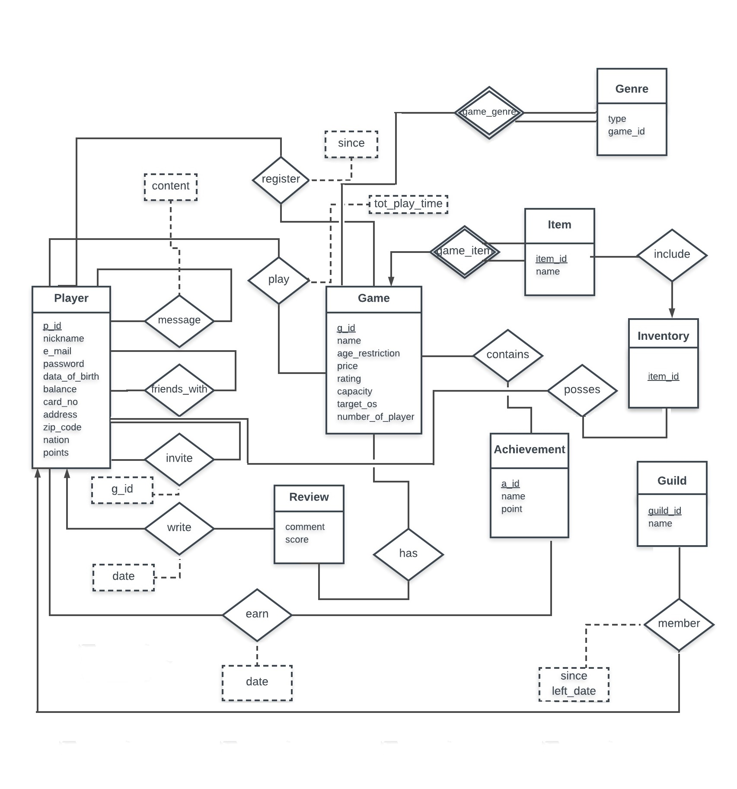

1. **Website**

Following is the site that has the documentation and the code for the project:

https://github.com/aliatli/SocialGamingMarketplace